**08 – Energy Flow in a Simple Circuit**

**Topics:** Poynting vector, boundary conditions, surface charges, Ohm’s law

**Summary:** These activities focus on the location and direction of energy flow for a circuit containing just a battery and a resistor; the initial tasks consider only a resistive element with a current flowing through it. Students should first conclude that energy is flowing radially into the resistor (and not along the direction of current), and that Faraday’s Law requires the electric field to be nonzero outside the resistor. With no volume charge density inside the resistor, the next conclusion is that surface charges are responsible for the perpendicular components of the electric field, which must vary along the length of the resistor for the field to be conservative. The final conclusion is that energy flows from battery to resistor through the fields outside the conducting wires, and that energy can (counter-intuitively) flow opposite the direction of current.

**Supporting Material:** I. Galili and E. Goihbarg, “Energy transfer in electrical circuits: A qualitative account” *Am. J. Phys.* **73**, 141 (2005).

**Written by:** Charles Baily, Michael Dubson and Steven Pollock.

**Contact:** Steven.Pollock@Colorado.EDU

**Comments:** Most students were able to complete these activities within 40 minutes. The part concerning the parallel components of the electric field outside the resistor (pg. 2) may be more challenging for students who did not complete the tutorial on boundary conditions. Determining the direction of the perpendicular components of the electric field can be difficult if students do not keep in mind the assumption that both of the perpendicular sides contribute equally to the line integral, as required if there are no other circuit elements (there is just a battery and resistor in this case, as stated on the first page). There were still a few students who believed the volume charge density inside the resistor is non-zero (even though the current is steady), so this activity gives another opportunity to address this (see #2-Ohm’s Law tutorial). Despite the wording on the final page, some students were still confused about the schematic diagram – they were concerned that the fields at the points indicated might be influenced by the distribution of charges elsewhere in the circuit. The final conclusion about the location and direction of energy flow was surprising to most students, and instructors should be sure that students don’t automatically assume the direction of energy flow is the same through the entire circuit (from positive to negative terminal, instead of outwards from both). Many students strongly associate the Poynting vector *only* with electromagnetic waves, so this activity provides another context for them. In a separate homework problem, we had students confirm that the total kinetic energy of the electrons that make up the current in the wire is completely negligible compared to the energy contained in the fields. This tutorial is loosely based on an *AJP* article by Galili and Goihbarg (cited above).

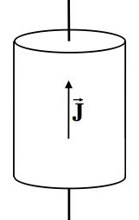**A.** A steady uniform current density  flows upwards through a cylindrical resistor (as shown in the diagram at right). The resistor is made from a poorly conducting material with high *resistivity* , where  is the *conductivity* of the material. The bottom wire is connected to the positive terminal of a battery, and the top wire is connected to the negative terminal.

This next diagram shows the same resistor in cross-section.

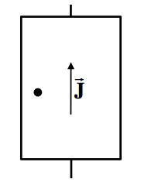

Indicate the direction of both the electric field  and the magnetic field  at the point shown **inside** the resistor (circular dot).

At this same point, draw an arrow indicating the direction of the Poynting vector:



Describe in words how energy is flowing into the resistor.

**B.** Consider an Amperian loop (dashed lines) with length  and width  that straddles the surface of the resistor.

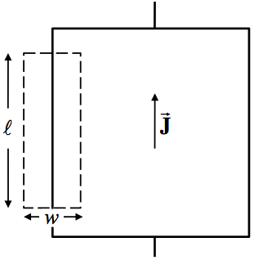

Recall Faraday’s Law:



Is the line integral of the electric field along this closed Amperian loop *positive*, *negative* or *zero*?

Briefly explain your reasoning.

Imagine we let  while keeping the loop centered on the wall of the resistor. In this situation, is the *parallel* component of the electric field outside the resistor *zero* or *nonzero*? Briefly explain your reasoning.

**C.** The total electric field must diminish as we move away from the resistor. The arrows inside the dashed region on the left represent the magnitude and direction of the parallel component of the electric field outside the resistor. Consider a line integral of the electric field  in the **counter-clockwise** direction. []

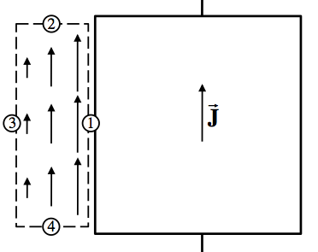

Is the contribution to the line integral from the parts of the loop that are **parallel** to the surface (1 & 3 only) *positive*, *negative* or *zero*?

Is the contribution to the line integral from the parts of the loop that are **perpendicular** to the surface (2 & 4 only) *positive*, *negative* or *zero*?

Indicate in the diagram the direction of the perpendicular component of the electric field  along parts 2 & 4 of the loop. Assume that both parts contribute equally to the line integral.

Is the volume charge density inside the resistor *positive*, *negative* or *zero?* Where are the charges located that are responsible for the perpendicular components of the electric field outside the resistor?

**D.** Suppose the steady-state surface charge on the resistor is distributed as shown in the diagram. The surface charge density varies smoothly from positive at the bottom to negative to negative at the top.

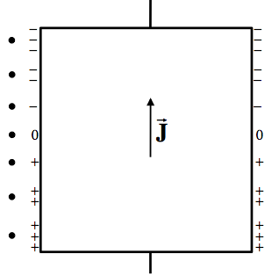

Sketch the magnitude and direction of just the perpendicular component of the electric field  at the points indicated just outside and to the left of the resistor (circular dots).

Suppose the resistor were *instead* an ideal conductor (). Would the parallel component of the electric field *just outside* this ideal conductor be *zero* or *nonzero*? [Hint: What happens to the electric field inside the material if the current density  remains finite as ?]

**E.** The diagram below depicts ideal conducting wires () that connect a battery with a resistor . The surface charge on the ideal conducting wires is roughly uniform, and varies smoothly from positive to negative on the surface of the resistor. [The diagram is schematic, so assume the nine circular dots shown in the diagram are lying just outside the circuit elements – the fields at each of the dots are not influenced by charges or currents in other parts of the circuit.]

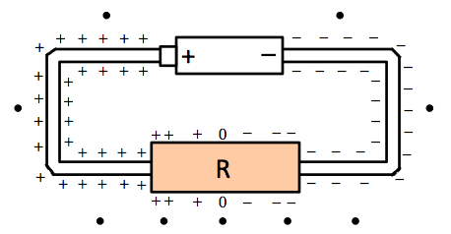

In the diagram above, sketch the direction of the total electric field  at each of the *nine* points indicated (circular dots).

At the same nine points, indicate the direction of the magnetic field  due to the current flowing through the circuit.

Now draw the direction of the Poynting vector  at each of these points.

From this information, describe in words how energy is flowing from the battery to the resistor. Where is the energy flowing, and in what direction(s)? Is energy flowing through the ideal conducting wires?